**Fragrantiz – Buy Arabian Oud, Bakhoor and Halal cosmetics online**

[**https://www.fragantiz.in/**](https://www.fragantiz.in/)

(Ecommerce store setup finished, on-page seo optimization completed. Google Analytics, Google webmaster and Google Adwords enabled. Rest all details in coming pages)

**Part. 1**

1. **Fragrantiz.in**, is an ecommerce site using woocommerce / Wordpress. The store is fully responsive and compatible to all devices. Also added all security tools like, SSL certificate for buyer protection and Anti-spam plugin to block spam comments.
2. **The store setup completed** with 150 products, 20 categories from 25 international brand products. 99% products selling through this store are imported items. Screen shots of home page listed below:-

**Home-page**

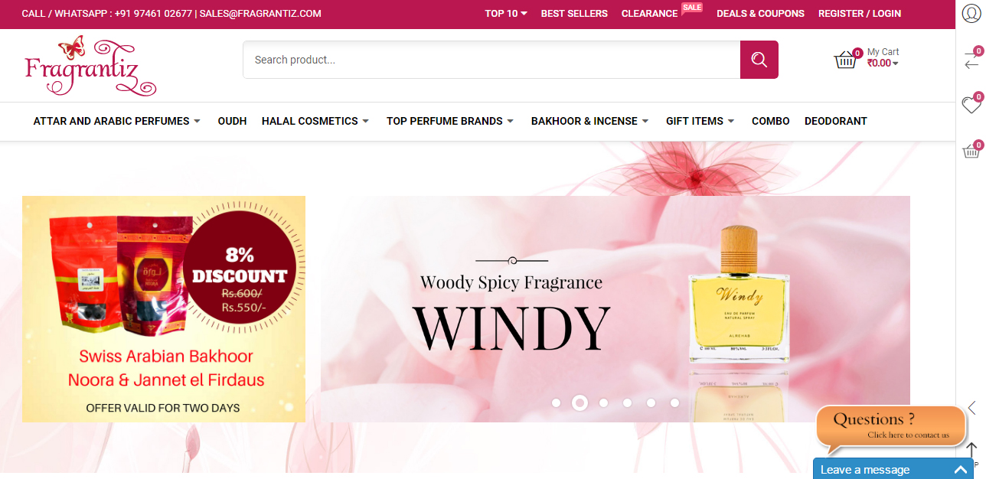

**Proudct listing**

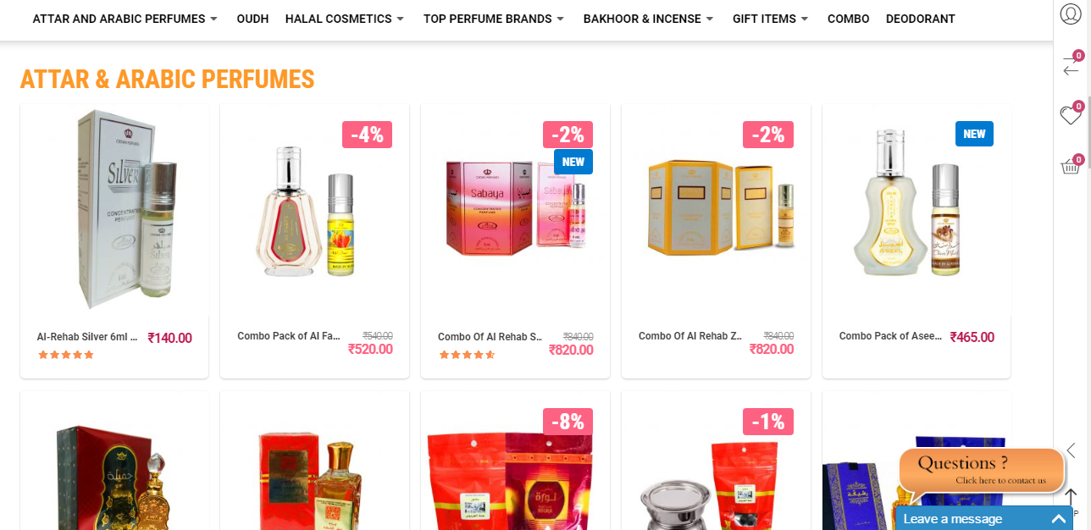

**Category listing view**

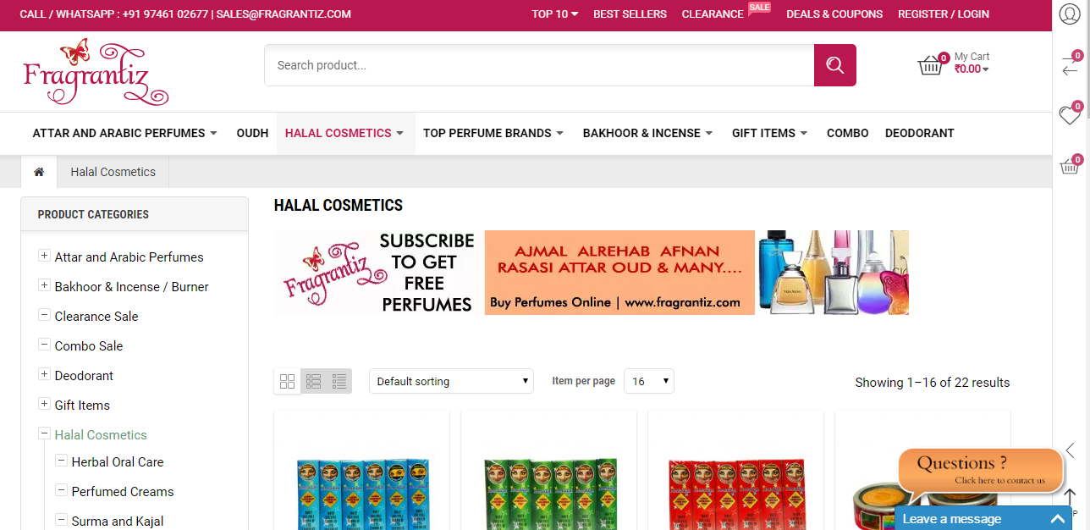

**Single Product Page**

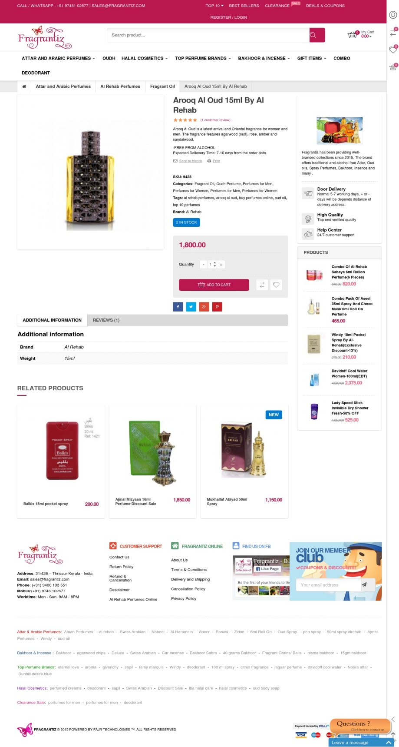

**Checkout Page**

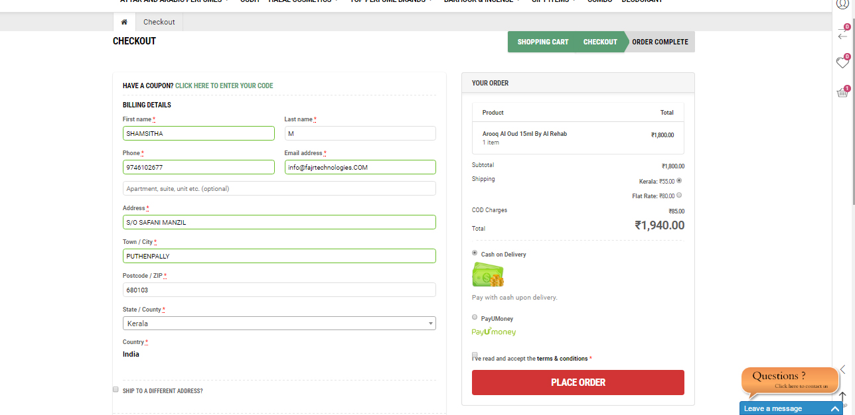

1. **For lead capture** – we using many methods

* Subscription form using Mailchimp
* Exclusive coupons
* Free products to token win customers
* Live chat support
* Whatsapp support
* Email support
* Call support
* Flexi payment methods (Advanced Pay with Payumoney payment gateway, Cash on Delivery, Paytm, Account Transfer, Direct pickup)

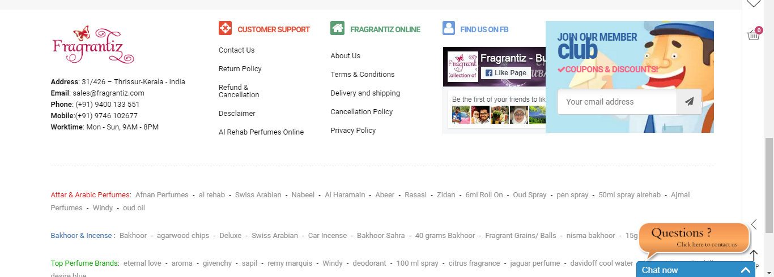

**Part. 2**

**1.On-Page SEO**

**Search Engine Optimization (SEO)** - The process of modifying attributes of a website to improve its position on one or more search engines, gaining visibility in front of the target audience. On-page seo completed for Fragrantiz.in

**On-Page Optimization:** Based on the finalized keywords we will create a detailed document that states the recommended SEO changes for the identified landing pages in terms of the following:

* Meta Tags Optimization
* Page Content Optimization
* Image Optimization
* Hyperlink Optimization

**2.Keyword Research and analysis**

**Keyword Research:** Done thorough research and analysis to determine the most relevant and popular keywords/key phrases for promotions. The keywords selected are based on 3 major factors Relevancy, Popularity and Compositeness. I use tools like Google Keywords Tool, Keyword/Discovery, Overture Keyword Tool, etc to determine the keywords.

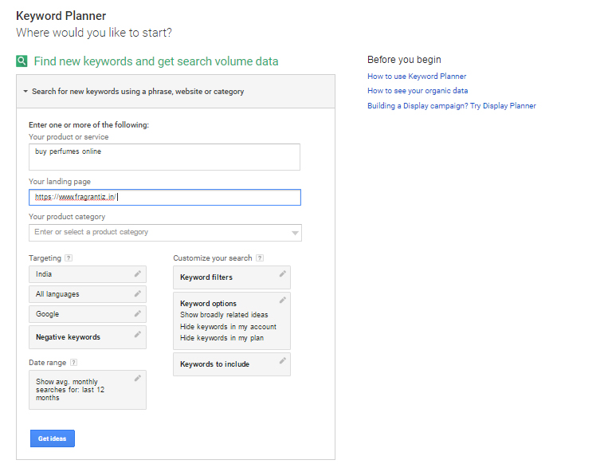

1. **Appropriate Page Titles for every page**

Fragrantiz.in is ecommerce site so titles and keywords actually unlimited. I

I optimized site as like Keywords oriented product tiles, pages and tags.

**Key word oriented Titles**

1. Attar and Arabic perfumes - <https://www.fragrantiz.in/product-category/attar-and-arabic-perfumes/>
2. Halal Cosmetics - <https://www.fragrantiz.in/product-category/halal-cosmetics/>
3. Oudh perfume - <https://www.fragrantiz.in/product-category/oudh-perfume/>
4. Top perfume brands - <https://www.fragrantiz.in/product-category/top-perfume-brands/>
5. Bakhoor and incense burner - <https://www.fragrantiz.in/product-category/bakhoor-incense-burner/>
6. Gift Items - <https://www.fragrantiz.in/product-category/gift-items/>
7. Deodorant - <https://www.fragrantiz.in/product-category/deodorant/>
8. Combo sale - <https://www.fragrantiz.in/product-category/combo-sale/>
9. Top 10 Perfumes - <https://www.fragrantiz.in/top-10-perfumes/>
10. Perfumes for women - <https://www.fragrantiz.in/product-category/perfumes-for-women/>
11. Perfumes for men - <https://www.fragrantiz.in/product-category/perfumes-for-men/>
12. **Ensure SEO Tags**

On page SEO has done using additional plugin – **All In One SEO Plugin.** In order to complete the On-Page SEO task I took 16 hrs including keyword research. Through a deep research on keywords using google keyword planner, I ve created a list of 75 to 125 keywords. Mainly I am following a method of – long tail keywords. (Title, Meta Description, H1 tag, Image alt tags. Fragrantiz.in is SEO optimized. )

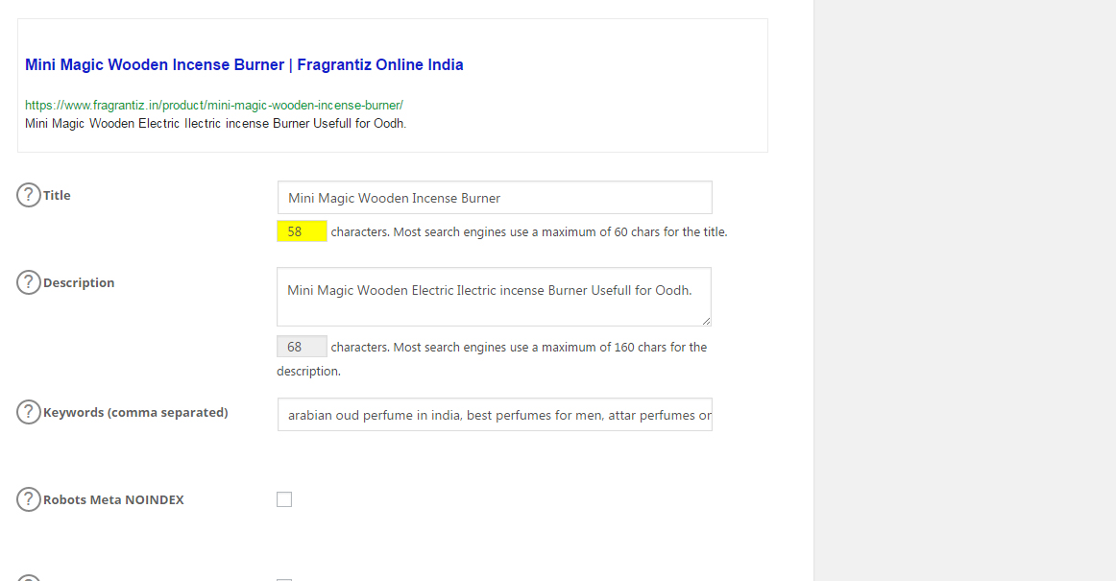

**Part. 3**

1. **Google Webmasters and verify the ownership done successfully.**

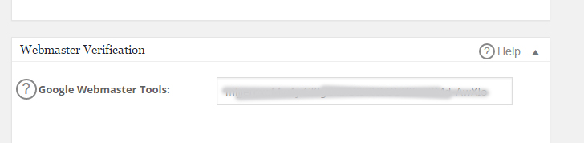

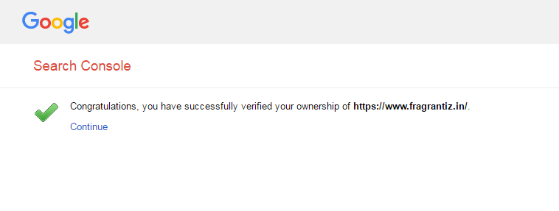

1. **Google Analytics (GA) created and GA tracking code setup to website done.**

**GA setup in website dashboard**

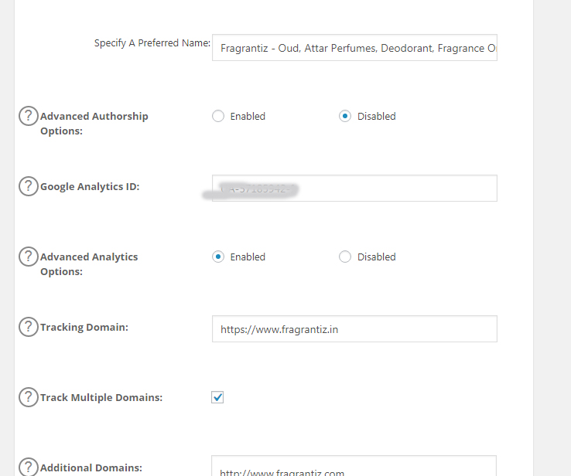

**Tracking code creation in Google**

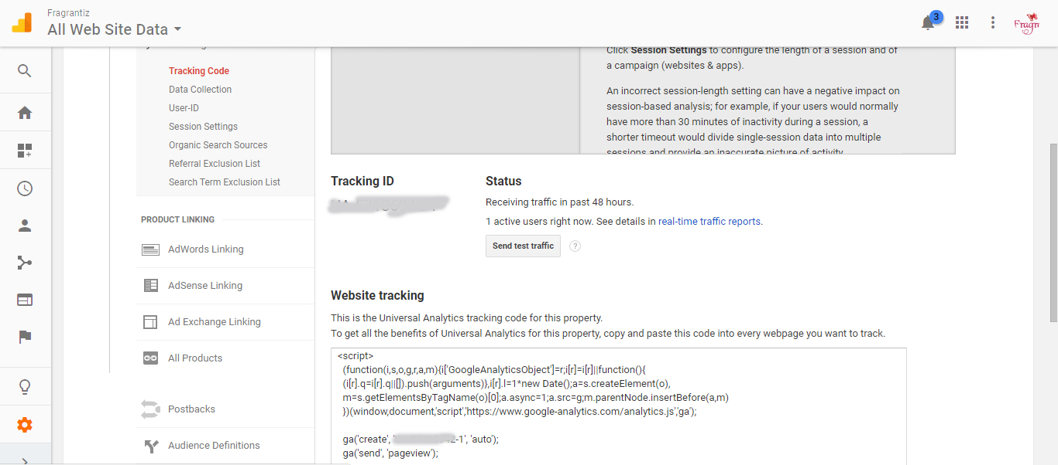

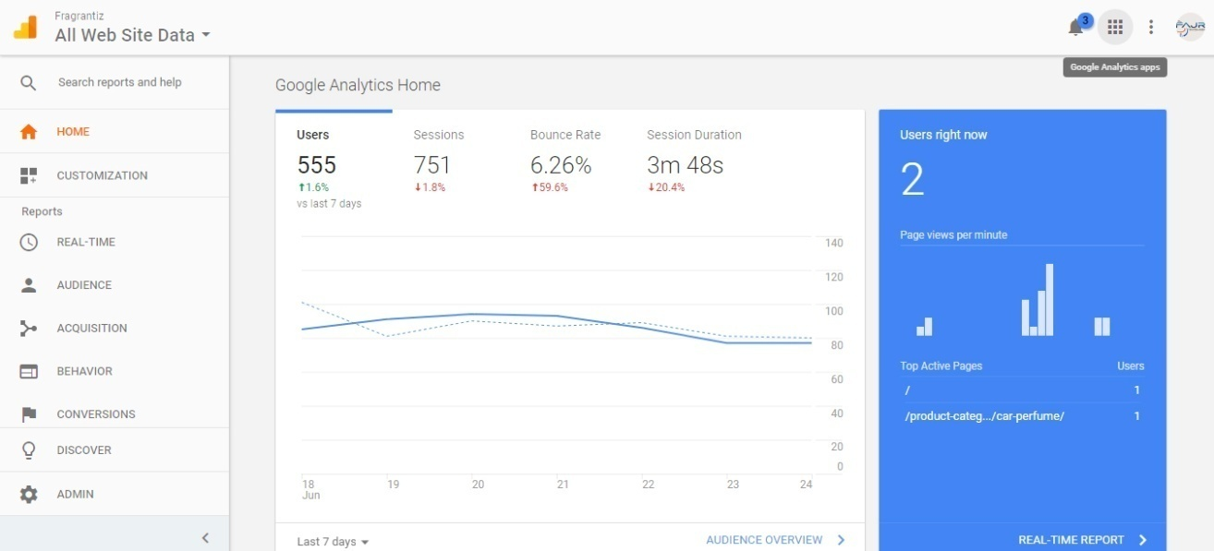

**Report of number of visitors, traffic location and traffic device**

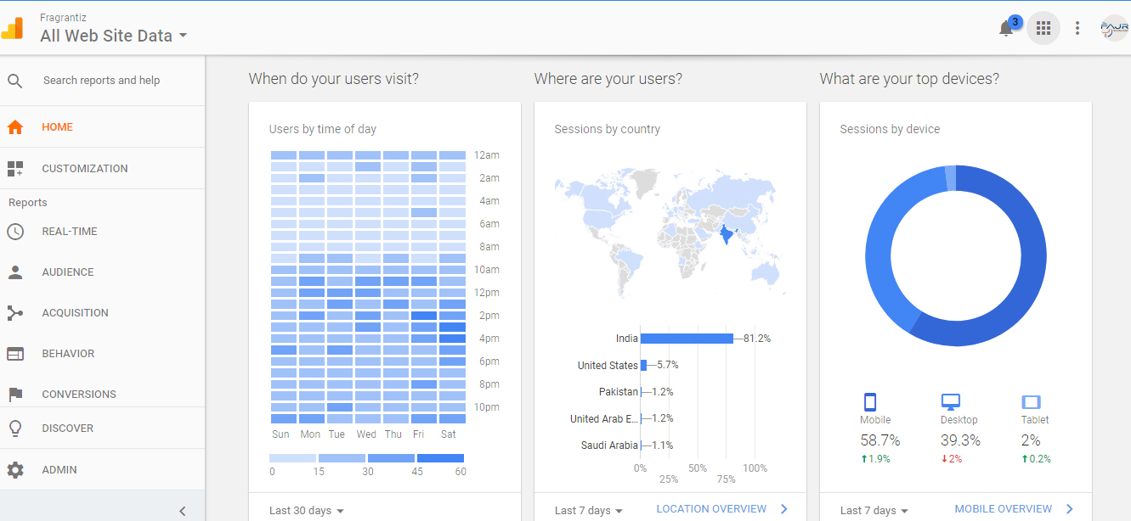

**Report of trending visitors**

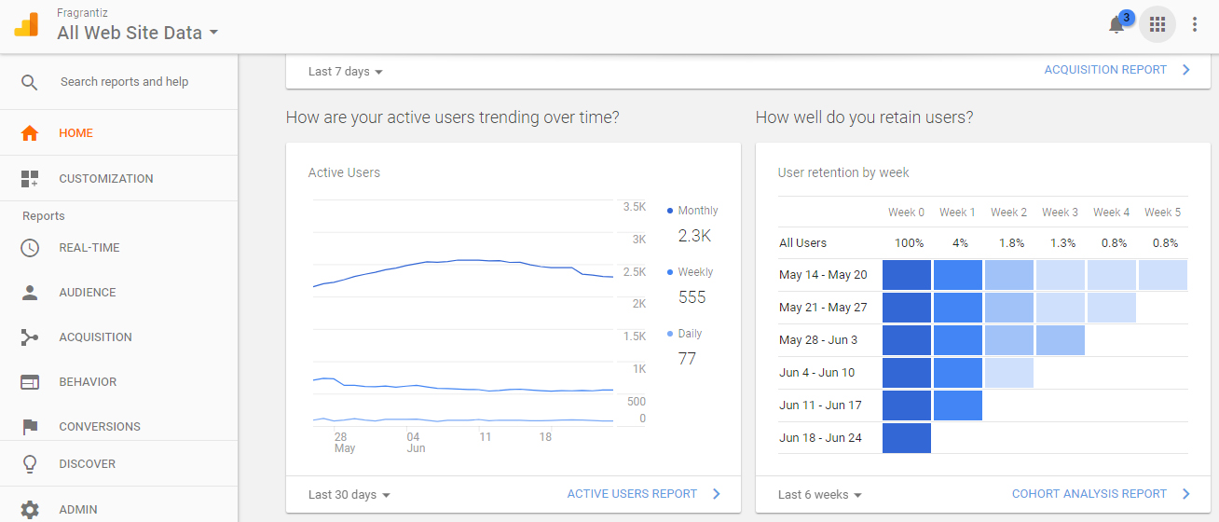

1. **Define the metrics to measure the success**
2. **Organic Traffic**

Organic traffic is the success of best SEO campaign. Through organic traffic we get more sales or conversions. But organic traffic is not easy to get it quickly.

When our on-page SEO comes in right way, organic traffic is not far from us.

1. **Conversions from organic traffic**

The main success of ecommerce site is conversion means sales. Better SEO will give us organic traffic, organic traffic will comes from some particular keywords. There is more possibility for conversion.

Paid campaign also will give us more sales, but the ad only will visible based on our investments.

Am putting target as 20% growth organic traffic in every 3 months. That will increase the sales.

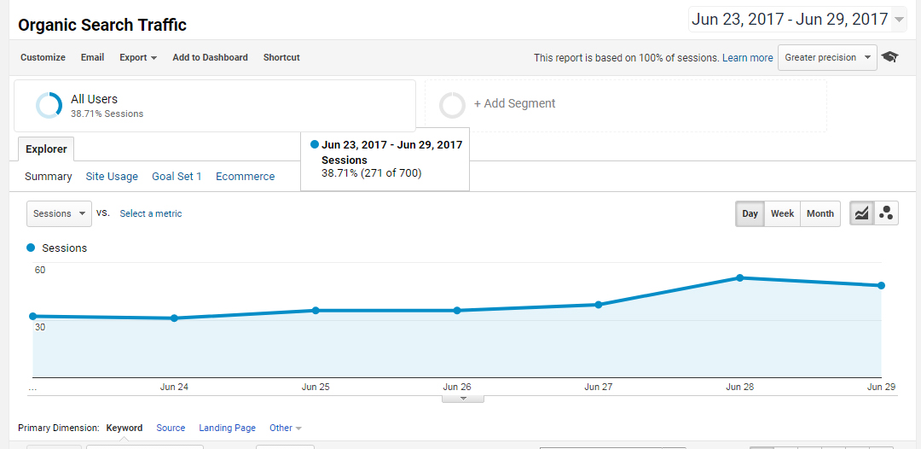

1. **Focus on new visitors or new customers**

Focus inReturning customers or existing customers is not good marketing methods. If you want to increase sales and improve the traffic, we must focus for new traffic and new customers.

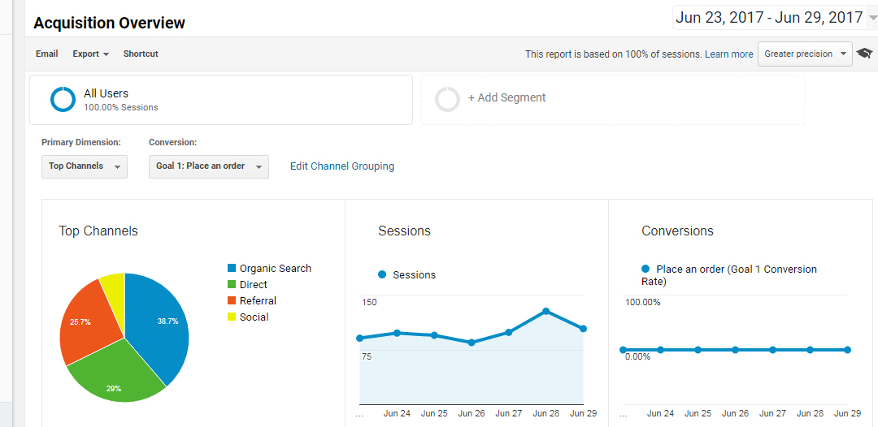

**d). Reduce Bounce rate and increase new session**

Bounce rate will give an idea about leaving people, so there is less possibility of conversion. Bounce always should be in lowest rate, which is good sign of site. Because those who visiting the site will be genuine visitors. We getting more relevant traffic also.

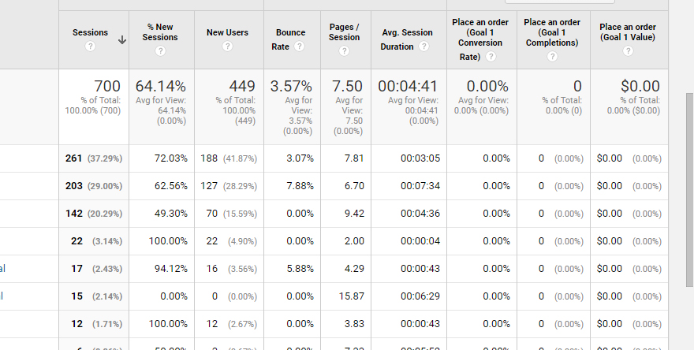

**e). Ranking**

Ranking is not easy task to get. It is the success of all our SEO campaigns, especially the On-Page SEO tasks. Ranking is important but rank and traffic are different. Conversion or sales we can attain only through traffic, conversion is possible through paid campaign or organic traffic. But the conversion from organic traffic will long last.

Ranking we getting from Google, We have to follow all policies of google to get ranking, we will get it gradually.

1. **Create a weekly and monthly reporting template**

Additional xls file added along with project file.

1. **Set up Goals in GA**

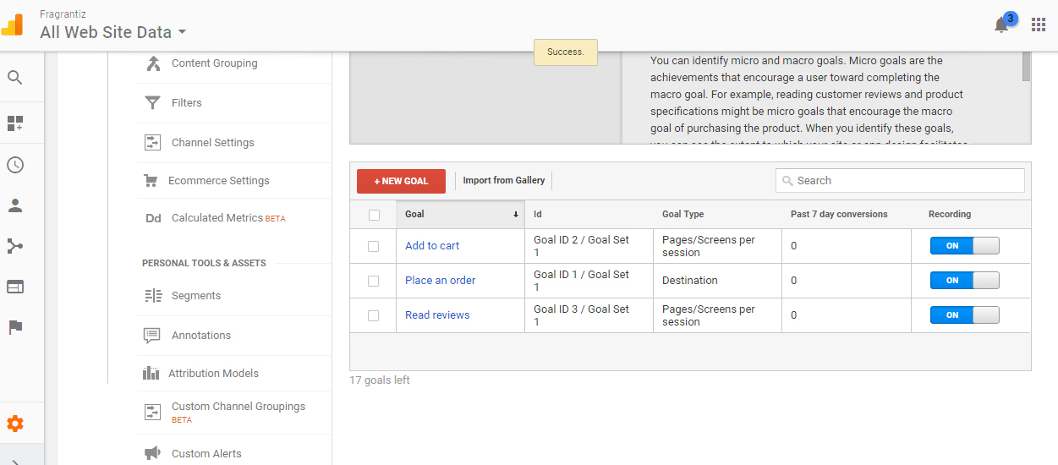

1. **Set up Google Adwords Account**

